The types of studies conducted, protocols used, and the results of the studies should be summarized. The summary should include, for example,

* conclusions with respect to storage conditions
* conclusions with respect to shelf-life, and
* in-use storage conditions
* In use shelf-life.

# **Stabilty summary and conclusion** QdrugInjectable solution

## **Stability summary and conclusion**

Lorem ipsum dolor sit amet, consectetuer adipiscing elit. Maecenas porttitor congue massa. Fusce posuere, magna sed pulvinar ultricies, purus lectus malesuada libero, sit amet commodo magna eros quis urna.

Nunc viverra imperdiet enim. Fusce est. Vivamus a tellus.

Pellentesque habitant morbi tristique senectus et netus et malesuada fames ac turpis egestas. Proin pharetra nonummy pede. Mauris et orci.

Aenean nec lorem. In porttitor. Donec laoreet nonummy augue.

Suspendisse dui purus, scelerisque at, vulputate vitae, pretium mattis, nunc. Mauris eget neque at sem venenatis eleifend. Ut nonummy.

**Table 1: Summary of Stability Study Batches of Qdrug Injectable solution**

|  |  |  |  |  |  |  |  |  |  |
| --- | --- | --- | --- | --- | --- | --- | --- | --- | --- |
| Batch # | Manufacturing date | API Lot | Fill volume/ Vial volume | Batch size | Use | Long term Stability | Photostability | Short term Stability | In use Stability |
| B123 | 1/1/2016 | 90338245 | 0.5 mL fill/ 0.8 ml vial | 1kg | Phase III | 36M at 5±3°C/ARH | Not performed | 3 months at 5±7°C/ARH | Not performed |
| B234 | 1/2/2016 | 90338345 | 0.5 mL fill/ 0.8 ml vial | 1kg | Registration stability | 24M at 5±3°C/ARH | Not performed | 3M at 21±3°C/ARH | Not performed |
| B345 | 1/3/2016 | 90338245 | 0.5 mL fill/ 0.8 ml vial | 2kg | Registration stability | 24M at 5±3°C/ARH | Not performed | 3M at 21±3°C/ARH | Not performed |
| Batchnr4:B456 | 1/4/2016 | 90338245 | 0.5 mL fill/ 0.8 ml vial | 2kg | Registration stability | 24M at 5±3°C/ARH | Not performed | 3M at 21±3°C/ARH | Not performed |

### **Long term stability**

Lorem ipsum dolor sit amet, consectetuer adipiscing elit. Maecenas porttitor congue massa. Fusce posuere, magna sed pulvinar ultricies, purus lectus malesuada libero, sit amet commodo magna eros quis urna.Suspendisse dui purus, scelerisque at, vulputate vitae, pretium mattis, nunc. Mauris eget neque at sem venenatis eleifend. Ut nonummy.

Lorem ipsum dolor sit amet, consectetuer adipiscing elit. Maecenas porttitor congue massa. Fusce posuere, magna sed pulvinar ultricies, purus lectus malesuada libero, sit amet commodo magna eros quis urna.

Long term stability studies have been performed, the product can be stored at LongtermStorageDuration:24M at LongtermStorageCondition:5±3°C/ARH.

Figure 1 Stability results by storage conditions

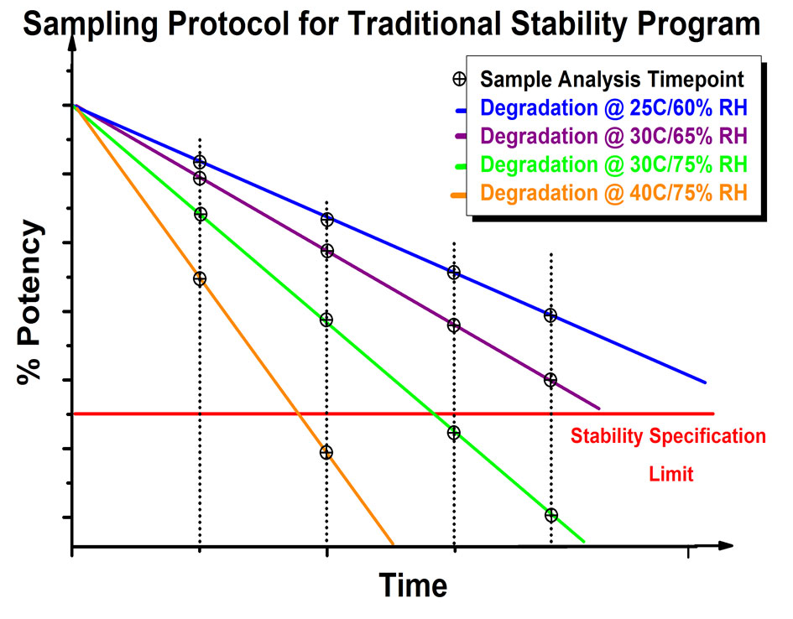

Nunc viverra imperdiet enim. Fusce est. Vivamus a tellus.

### **Photostability**

PhotostabilityConclusion: No photostability studies have been performed, so the product must be protected from light.

### **Short term stability**

Pellentesque habitant morbi tristique senectus et netus et malesuada fames ac turpis egestas. Proin pharetra nonummy pede. Mauris et orci.

Aenean nec lorem. In porttitor. Donec laoreet nonummy augue.

Short term stability studies have been performed, the product can be stored at ShorttermStorageDuration:3M at ShorttermStorageCondition21±3°C/ARH.

### **In use stability**

In-useStabilityConclusion:In-use stability studies have been performed, so the product must be used immediately.

## **Overall conclusion**

All stability testing results obtained for registration batches (BatchNumber:B123, BatchNumber:B234, BatchNumber:B345, BatchNumber:B456), met the stability specifications Based on the stability study results DrugProduct:Qdrug DosageForm:Injectable solution can be stored for LongtermStorageDuration:24M at LongtermStorageConditions:5±3°C/ARH or at ShorttermStorageDuration:3M at ShorttermStorageCondition21±3°C/ARH

In-useConclusion:After first opening the medicinal product should be used immediately.

PhotostabilityConclusion:No photostability studies have been performed, so the product must be protected from light.

In-useStabilityConclusion:In-use stability studies have not been performed, so the product must be used immediately.